Autumn Term 2 Instant Recall Number facts to learn – Year 2
The aim of instant recall facts is that children know these facts instantly, without having to resort to saying a rhyme or using their fingers.
Number Bonds to 20
Children know addition and subtraction facts for numbers up to 20. These are sometimes referred to as number bonds – pairs of numbers that make 20. Children also need to be able to recall instantly the corresponding subtraction facts.
The secret to success is practising little and often. Use time wisely. Can you practise these facts while walking to school or during a car journey? You don’t need to practise them all at once: perhaps you could have a fact of the day.
Use what you already know – Use number bonds to 10 (e.g. 7 + 3 = 10) to work out related number bonds to 20 (e.g. 17 + 3 = 20).
Use practical resources – Make collections of 20 objects. Ask questions such as, “How many more conkers would I need to make 20?”
Make a poster – We use Numicon at school. You can find pictures of the Numicon shapes here: bit.ly/NumiconPictures – your child could make a poster showing the different ways of making 20.
Play games – You can play number bond pairs online at www.conkermaths.com and then see how many questions you can answer in just one minute.
Key Language you could use: ‘What is 5 add 15?’ ‘What is 12 plus 8?’ ‘What are the different parts of 20?’ ‘What is 20 take away 6?’ ‘What is 3 less than 20?’

0+20=20  1+19=20  2+18=20  3+17=20  4+16=20  5+15=20  6+14=20  7+13=20  8+12=20  9+11=20  10+10=20  11+9=20  12+8=20  13+7=20  14+6=20  15+5=20  16+4=20  17+3=20  18+2=20  19+1=20  20+0=20 | 20-0=20  20-1=19  20-2=18  20-3=17  20-4=16  20-5=15  20-6=14  20-7=13  20-8=12  20-9=11  20-10=10  20-9=11  20-8=12  20-7=13  20-6=14  20-5=15  20-4=16  20-3=17  20-2=18  20-1=19  20-0=20

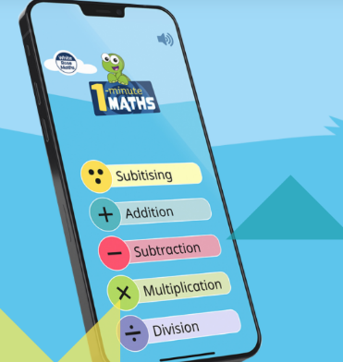
White Rose Maths has a free app that you can download with games that support children’s instant recall of these facts.

